Boolean Logic Extra Credit – Multiplexers Explained

*Multiplexing* is the generic term used to describe the operation of sending one or more analogue or digital signals over a common transmission line at different times or speeds. A multiplexer, or data selector, is a combinational logic circuit designed to switch one of several input lines through to a single common output line by the application of a control signal. A multiplexer of 2n inputs has *n* select lines. Multiplexers are mainly used to increase the amount of data that can be sent over the network within a certain amount of time and bandwidth, economizing connections over a single channel, or implementing Boolean functions of multiple variables. Smaller multiplexers can be chained together to created larger multiplexers (e.g. 8-to-1 multiplexer can be made with two 4-to-1 and one 2-to-1 multiplexer, creating a chained total number of selector inputs of 3).

Multiplexers are often coupled with a complimentary demultiplexer, a device that takes a single input signal and selects one of many data output lines, on the receiving end.

**2-input Multiplexer Switch**

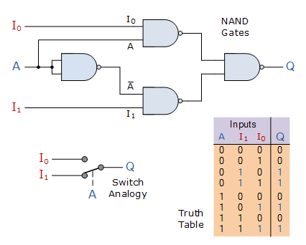

../../../../Desktop/Screen%20Shot%202017-03-09%20at%208.50.30

../../../../Desktop/Screen%20Shot%202017-03-09%20at%208.50.35

**4-to-1 Channel Multiplexer**

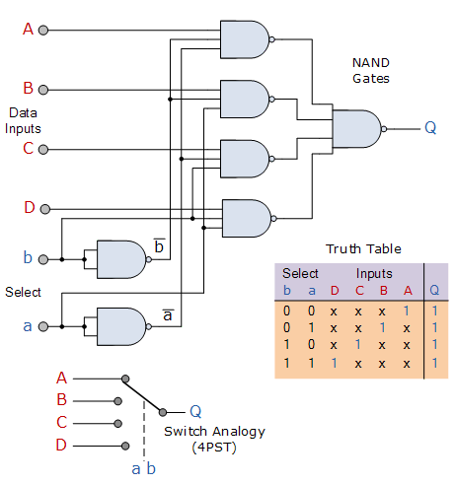

../../../../Desktop/Screen%20Shot%202017-03-09%20at%208.56.34

**4-to-2 Channel Multiplexer**

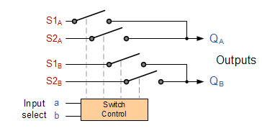

**Resources:**

1. <https://en.wikipedia.org/wiki/Multiplexer>
2. <http://www.electronics-tutorials.ws/combination/comb_2.html>